Cosmetic Tattooing by Riana
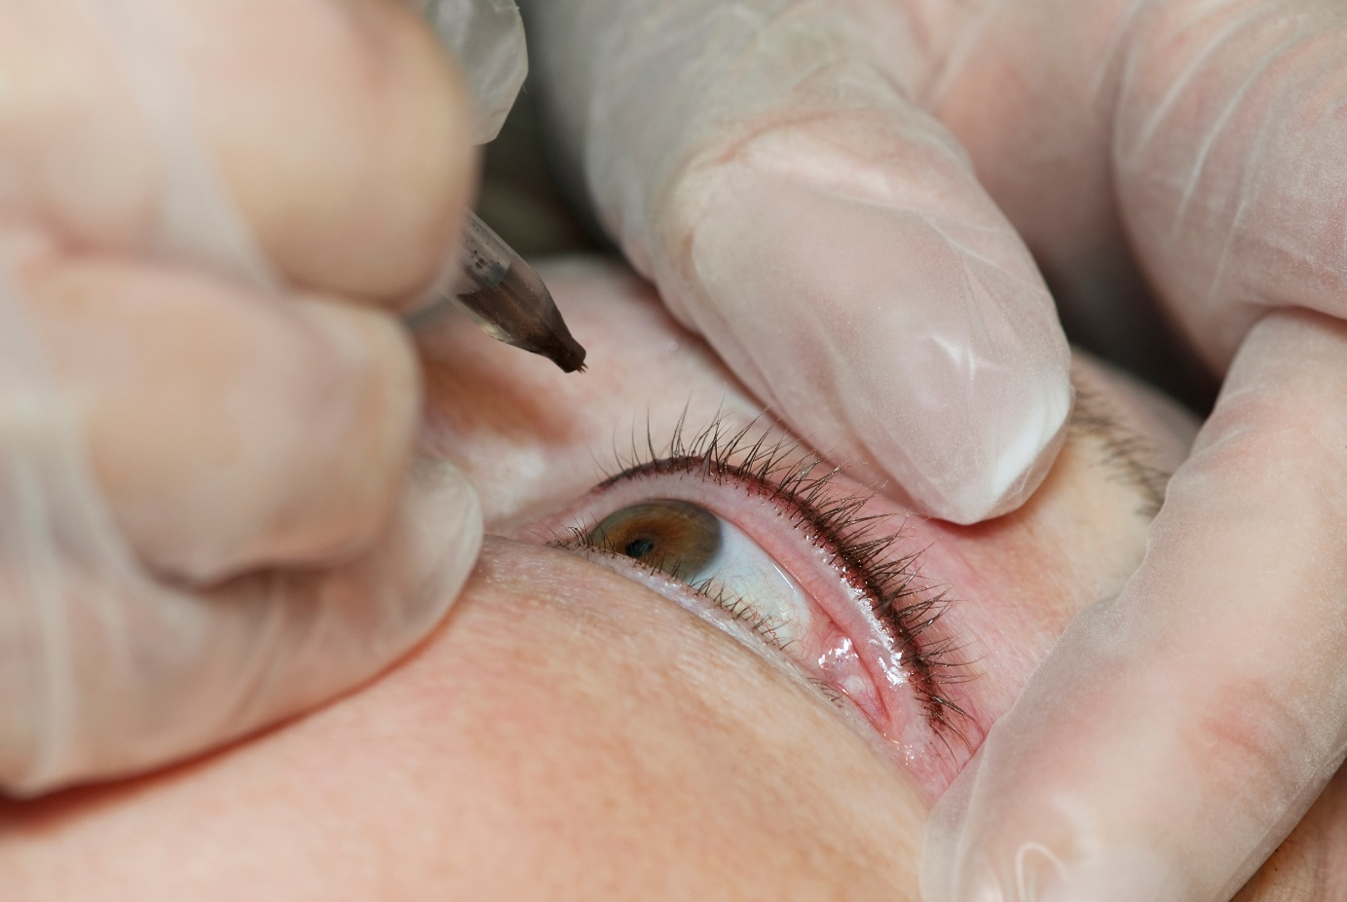
Thin top eyeliner in black
Procedure:
Consultation
Discuss design and colour
Consent
Apply anaesthetic (Clients own)
Leave anaesthetic on for 45 min
Tattooing according to discussed design and colour
Tattooing takes between 45 – 60 min
Follow home care advice

Full lip design
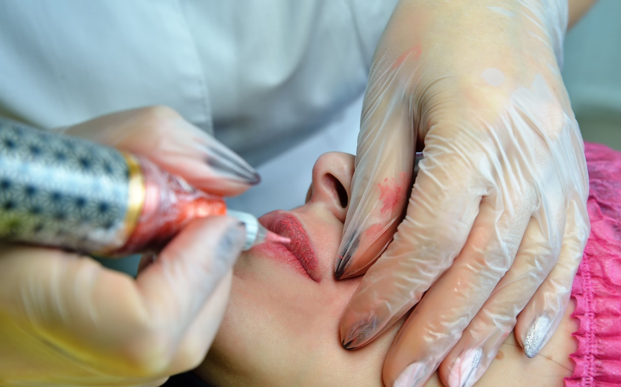
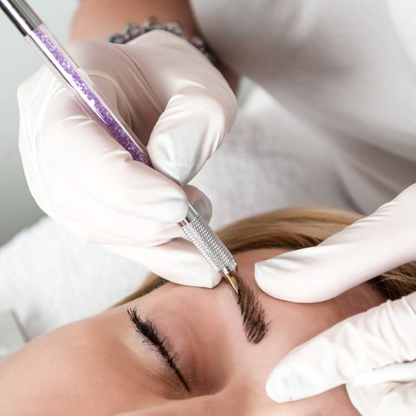
Brow microblading
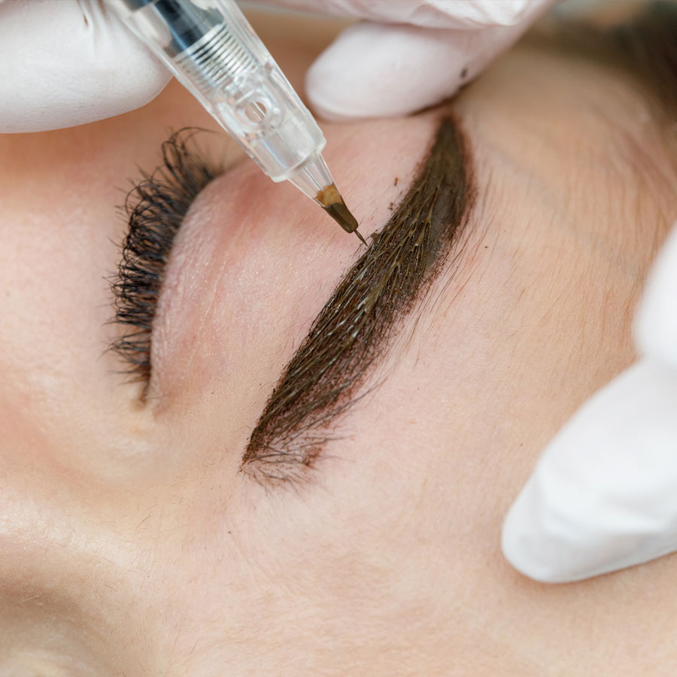
Eye brow shading = Full Eyeliner with small wing
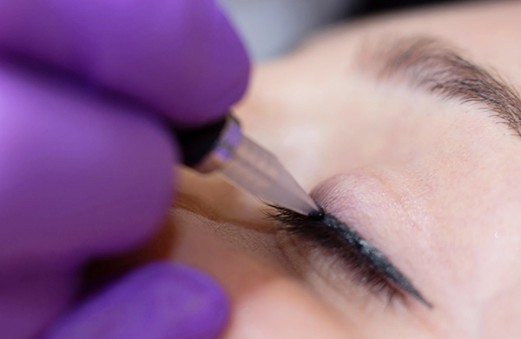
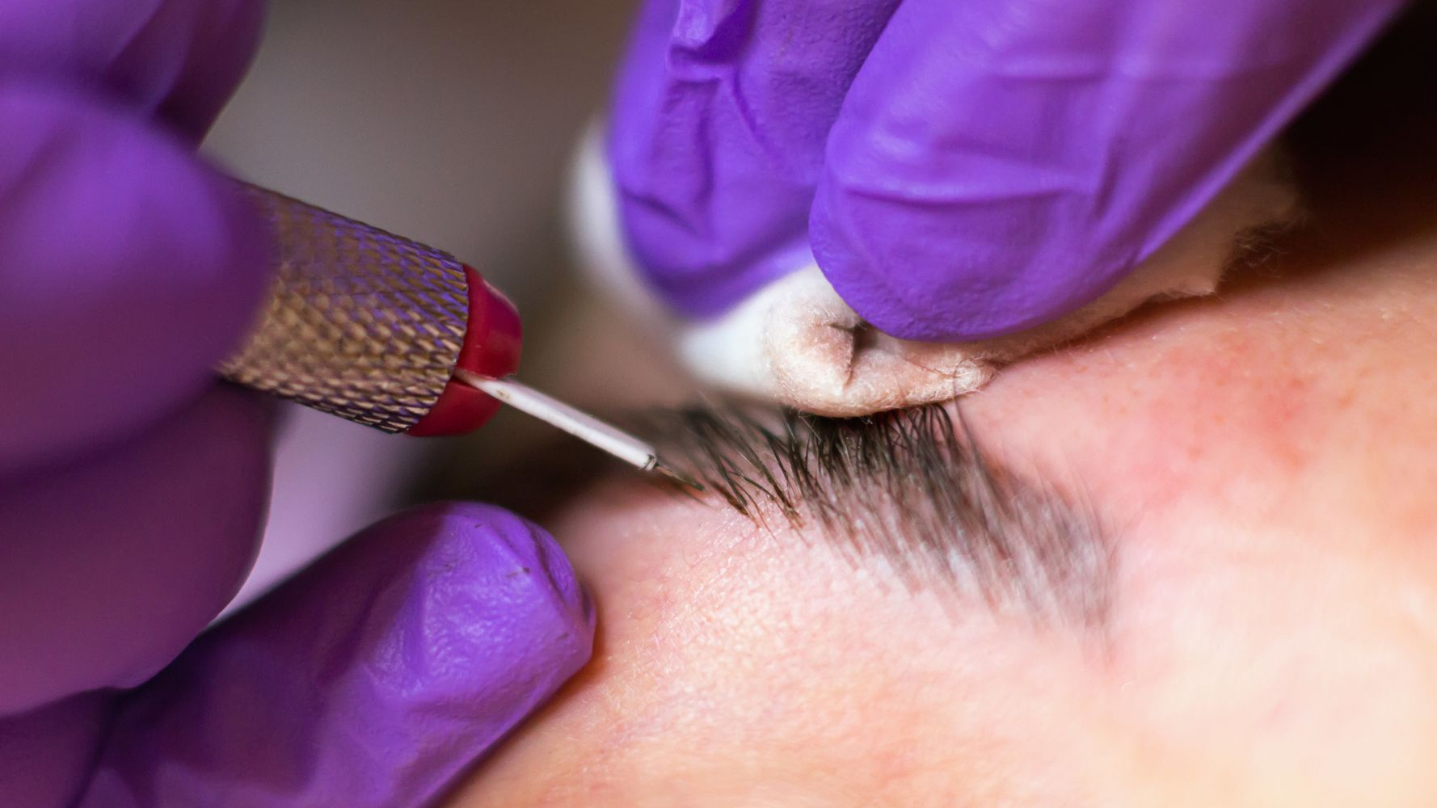
Eyebrow microblading
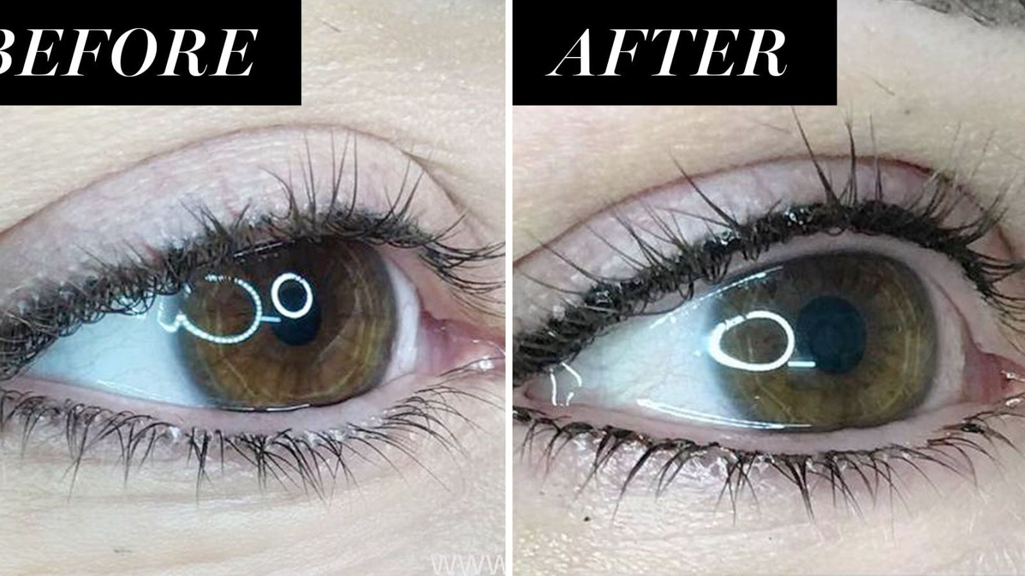
Eyeliner top and bottom

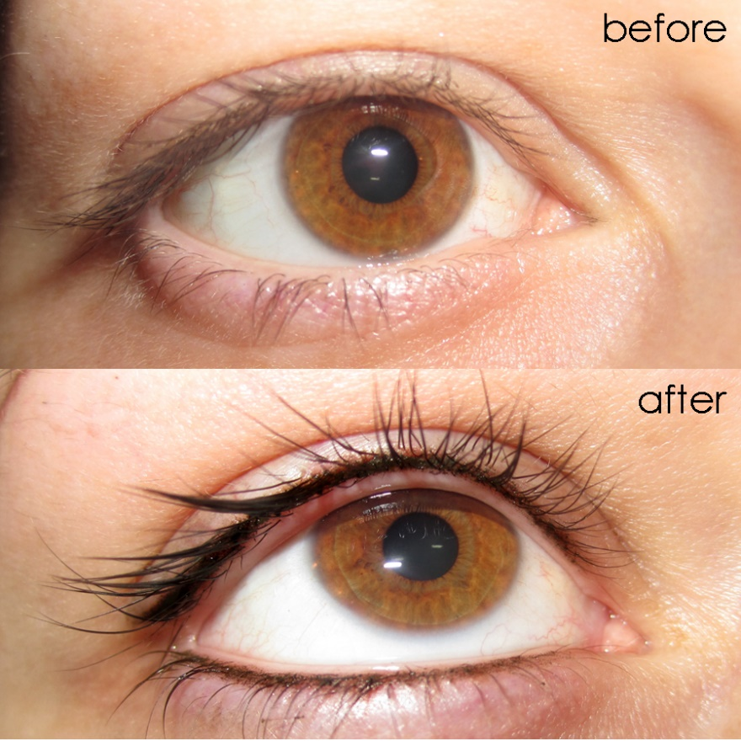
Eyeliner top and bottom
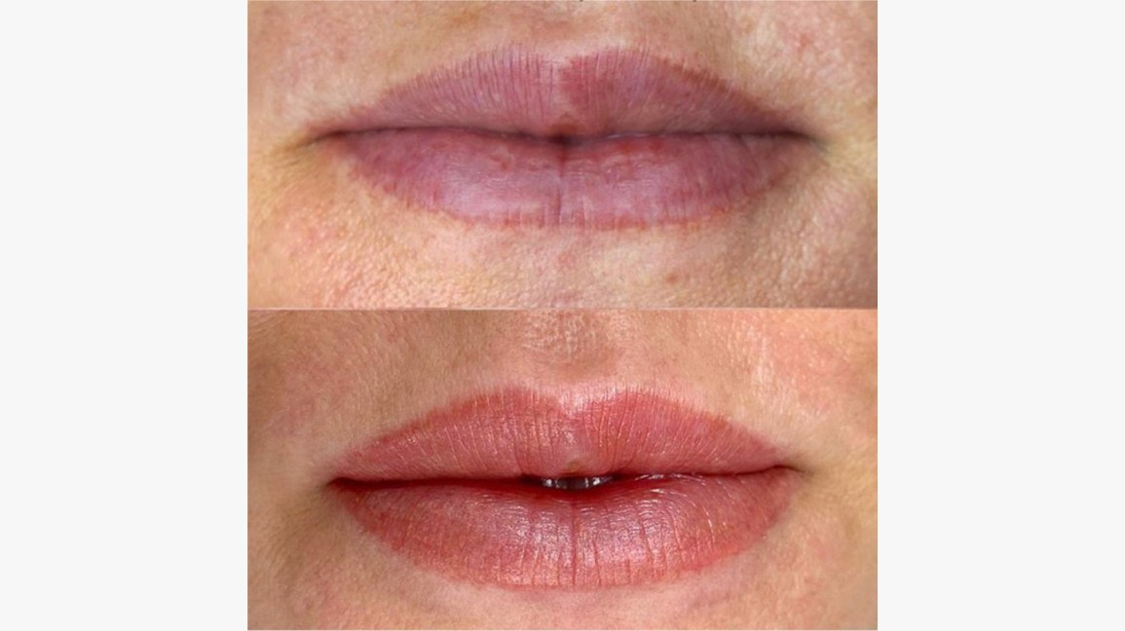
Full lip colour
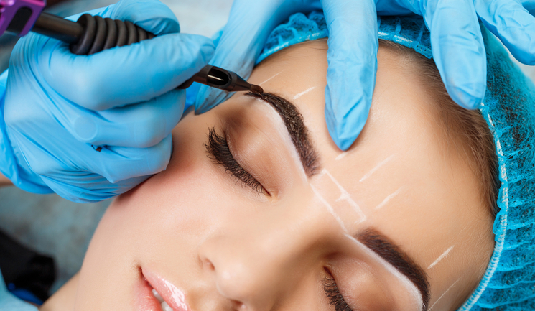
Full brow colour

- With all tattoos, the procedure is:
- Consultation
- Discuss design and colour
- Consent
- Anaesthetic (clients own)
- Tattoo procedure
- Home care advice
- Cost varies depending on the procedure

